CMDS 2026 Template for Abstract

Adam AuthorA,¹ Brenda AuthorB,² ..... , Nancy AuthorN^{1*}
¹First author's affiliation, Country;
²Second author's affiliation, Country. ...
E-mail: corresponding author's e-mail address
Please submit the abstract in Microsoft Word format (*.doc). The abstract should be written in English within the ONE-PAGE limit, including figures and tables. Please follow the format and style described below, or directly use this template.
The abstract should be typed in A4-page format (210 mm × 294 mm), leaving upper and bottom margins of 25.4 mm and left and right margins of 25.4 mm. Do not add page or abstract number to the abstract.
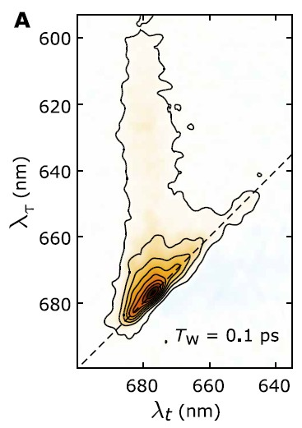
The font for the Title is 14 point Calibri Light with the first letter of each word capitalized and the text centered. Leave a blank line after the Title.
Fig. 1. 2D spectrum of a complex molecular system.
The font for the rest of the text is 11 point Calibri Light and the paragraph style is single-spaced (please check off the grid format when setting the paragraph style). Author’s names (centered) are written with given name first followed by family names (e.g., Adam Author, Ho Ho Lee, ..etc..). Multiple authors are separated by commas. If the authors are from different affiliations, number superscript can be marked to distinguish. Please mark the corresponding author with a superscript “*” and underline the presenting author’s name. Authors’ affiliations (italic, centered) should be separated by semicolons (;). Please provide the E-mail address of the corresponding author (centered). Leave one blank line before starting the main text of the abstract. The main text should be justified on the two sides, the paragraphs should not be indented. Please integrate Figures or Tables in the main text, with sufficient thickness for line plots and sufficiently high resolution for photos.

References (Optional) should be indicated in the text in square brackets and listed at the end of the paper (10 points), with an indent of 7.5 mm [1].
References
- T. A. First, T. Second, Anal. Chem., 15 (2005) 24-27.
- A. First in Mass Spectroscopy (A. B. Editor, ed.), Publisher: City, 2006, pp 111-120.
- R. F. Aroca, Surface-enhanced Vibrational Spectroscopy. Wiley: Chichester, 2006.

