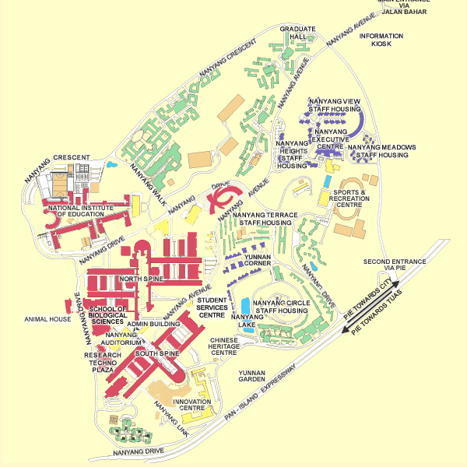  NanoCluster, Level 5 | E

Map of NTU: Overall view

Link to map:

http://www.street-directory.com/ntu/campus.cgi?sizex=600&sizey=600&star=&ismap=1&x=1630&y=1681&level=1?300,299

