pdated
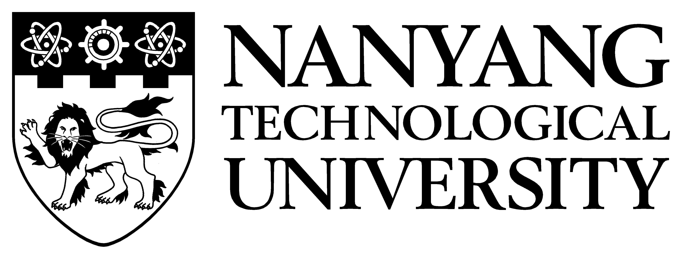 | School of Art, Design & Media  ADM Internship  for 3rd Year ADM Students

Background and Objective of ADM Internship

ADM Internship is an optional programme for our third year students from School of Art, Design & Media (ADM). The students will graduate from the 4-year degree programme with Bachelor of Fine Arts.

The curriculum is based on a common Foundation core in year one. Students may choose to specialize in the following from year two: Digital Animation, Digital Filmmaking, Photography & Digital Imaging, Interactive Media, Product Design and Visual Communication.

For more details on the curriculum, please visit the School’s website: http://www.adm.ntu.edu.sg/Programmes/Undergraduate/Pages/Home.aspx

The objective of the ADM Internship is to instill in students a sense of professionalism and the right work attitude so that they become effective and productive in their respective organisations much sooner than is usual.

Allowance & Working Hours

The recommended allowance is $1,000 and the minimum allowance should be $800. As a guide, most organisations are paying $800 to $1500 per month. Employers are exempted from making CPF contributions on student allowance. For overseas internships, this subsistence allowance is paid to student to meet his/her daily expenses and lodging. Students will follow the normal working hours of the organisation on a five-day or five-and-a-half day week basis.

Insurance

Students are covered against personal or bodily injuries caused by or arising out of accidents through a Group Personal Accident Insurance Scheme (24-hour worldwide) arranged by NTU. The University has also taken up a Public Liability Policy Insurance to indemnify organisations against claims and damages arising as a result of an act committed by NTU’s students in the course of the attachment. The territorial limit for this coverage is worldwide, excluding countries under international sanctions.

Procedure for Participation

Organisations are invited to offer placements and submit programme to NTU as early as possible or by end Dec 2017. Faculty supervisor from the School of Art, Design & Media will evaluate the programmes submitted by participating organisation for acceptance. Accepted programmes would be put up for students’ selection.

Selection and Allocation of Students

All participating organisations are required to interview students or select students from applications to ensure a good fit. This will ensure that the programme will be of value to both the supervisor and the interns.

The interview period is scheduled from mid Feb to 9 March 2018 at the organisation’s premises.

Note that students can apply up to five organisations for internship and they will decide which to accept if they receive multiple offers.

Supervision & Assessment of Student’s Performance at Work

Organisations should assign a supervisor who is trained in the arts / design / media to be responsible for the students in terms of work assignment and guidance, as well as to assess the performance of the students.

The organisation supervisor will be required to provide feedback on the students’ performance to the NTU faculty supervisor during the internship period. For overseas attachment, there is no visit by NTU faculty supervisor. The supervisor will also need to complete an evaluation form once to assess the performance of the student.

Certificate of Accomplishment

Students who successfully complete the ADM Internship will be awarded a Certificate of Accomplishment signed by the Director, Career & Attachment Office.

For further queries, please contact Ms Jenny Lim at 6790-4018 or email limsk@ntu.edu.sg.

Form 40

NANYANG TECHNOLOGICAL UNIVERSITY

School of Art, Design & Media (ADM Internship)
14 May 2018 – 21 July 2018 (10 weeks)

It takes about 1 minute to complete this information. You need to know the number of interns needed by your organisation. Please return completed form to Director, Career & Attachment Office, NTU, 50 Nanyang Avenue, South Spine, SS3-B2-15, S’pore 639798 or Fax 67937925 or email: limsk@ntu.edu.sg

[Part I. Contact Person Info]
Name: | (Dr/Mr/Mrs/Mdm/Miss)
Designation: |  |  |  |  | Email:
Organisation:
Address:
Tel: |  |  |  |  | Fax:

[Part II. Participating Organisation Info]
1. | Brief description of organisation’s business activities:
2. | Industry classification:
3. | Organisation website URL (if any):
4. | Type of organisation: (Please tick the appropriate box):
Local Ownership# Foreign Ownership# Government-Link Company
Statutory Board Government Department/Ministry
# based on majority shareholdings
5. | Please state if internship is a pipeline for graduate recruitment for your organisation: Yes No
6. | We recommend that all participating organisations either interview students or shortlist them from applications to ensure a good fit. Interview period is scheduled from mid Feb to 9 Mar 2018 at the organisation’s premises.  Students will submit a cover letter and resume (inclusive of the academic results). If you require students to submit other documents, portfolios or work, please state here:  ___________________________________________________________________________________________
7. | Allowance (CPF exempted): Non-indication of this section will result in a delayed application as further correspondence and clarification will be required.  Paid Internship, State allowance $ per month (recommended allowance of $1000)  Non-paying Internship
8. | Remarks, if any:

Form 41

NANYANG TECHNOLOGICAL UNIVERSITY

School of Art, Design & Media (ADM Internship)
14 May 2018 – 21 July 2018 (10 weeks)

It takes about 2 minutes to complete this form. You need to have the supervisor’s contact information and the description of work for the interns. Please complete and return to Director, Career & Attachment Office, NTU, 50 Nanyang Avenue, South Spine, SS3-B2-15, S’pore 639798 or Fax 67937925 or email limsk@ntu.edu.sg

- Please make copies of this form if you have more than one programme.
- Students will be provided with this programme description when they select organisations for their internship.
- Upon successful placement, organisation supervisor will need to provide a detailed training programme.
Note:
The School of Art, Design & Media (ADM) students specialize in one of the following areas:
Digital Animation • Digital Filmmaking • Photography & Digital Imaging
Interactive Media • Product Design • Visual Communication.

To encourage cross-division learning, students are allowed to apply for internship in any of the above areas as long as they meet the pre-requisite stated by the organisation. Companies are encouraged to have an understanding of the courses taken by our students before making an application. This will ensure that the organisation attracts the right candidates and that the internship will be of value to both the organisation as well as the student intern.

For more information on the school’s curriculum, please visit the following website:
http://www.adm.ntu.edu.sg/Programmes/Undergraduate/Pages/Home.aspx

Total no. of students required for this programme:
Job Scope Description:
(please provide as much details as possible so as to attract the right candidate for your organisation)
Pre-requisites (specific specialization, if any, language skills, computer skills, etc.):
(please provide as much details as possible so as to attract the right candidate for your organisation)
If students are to be attached to branch or subsidiary, please state address of attachment.

Name of the branch / subsidiary:
Address:

** Please continue onto the next section on Internship Organisation Supervisor allocation

Internship supervisor allocation

It is important that the organisation assign a supervisor with an art/design/media background for the student(s) to ensure a mutually beneficial internship. The supervisor will be responsible for the students’ work assignment and guidance, as well as to assess the performance of the student throughout the entire internship.

Non-indication of supervisor background and incomplete information may result in a delayed application as further correspondence and clarification will be required.

Organisation Supervisor for the above programme: |  |  |  |  | (To be completed by CAO, NTU)
Name: | (Dr Mr Mrs Mdm Miss)
Designation: |  |  |  |  |  | Orgn Code:
Art/Design background? | YES / NO Any other remarks:
Email: |  |  |  |  |  | Pgm Code:
Telephone: |  |  | Fax:

For further queries, please contact Ms Jenny Lim at 6790-4018 or email limsk@ntu.edu.sg.

Reporting Instructions for ADM Student

To: Director, Career & Attachment Office
Nanyang Technological University
South Spine, SS3-B2-15
50 Nanyang Avenue
Singapore 639798
Fax: 6793 7925

_____________________________________________________________________________________

ADM Internship Programme

14 May 2018 – 21 July 2018 (10 weeks)

Organisation Name | :
Address | :
Contact Person / Title | :
Telephone / Fax | :
Email Address | :
Reporting Officer / Title  (1st day of reporting only) | :
Date of Reporting | : | 14 May 2018
Time of Reporting | :
Working Hours | : | From  From |  | To |  | ( Monday - Friday )  ( Saturday, if applicable )
 |  |  |  | To
Allowance  (CPF exempted) | : | $ (Recommended allowance of S$1000 per month)
Dress Code | :
Special Instructions to students, if any | :
Completed by: |  |  |  |  |  |  | Date :
Name / Signature | :

